Deseq2 with gene lists walk through

Step 1) Copy our scripts

Log in to the super computer

Make a directory /scratch/User/yourusername/day7/

Cd into the new directory

Copy the two scripts we have provided in

/scratch/Shares/public/sread2021/scripts/day10/Deseq2_to_go/

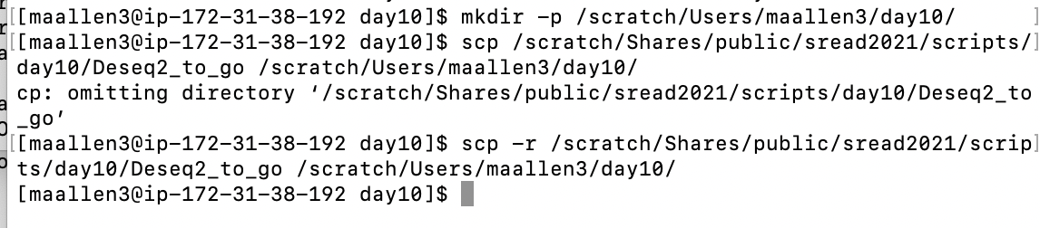

Step 2) Edit Our scripts

In the R script Change your working directory

In the sbatch script change your email and error and output files

####Make sure the error and output directory exist before you run!!!!!!



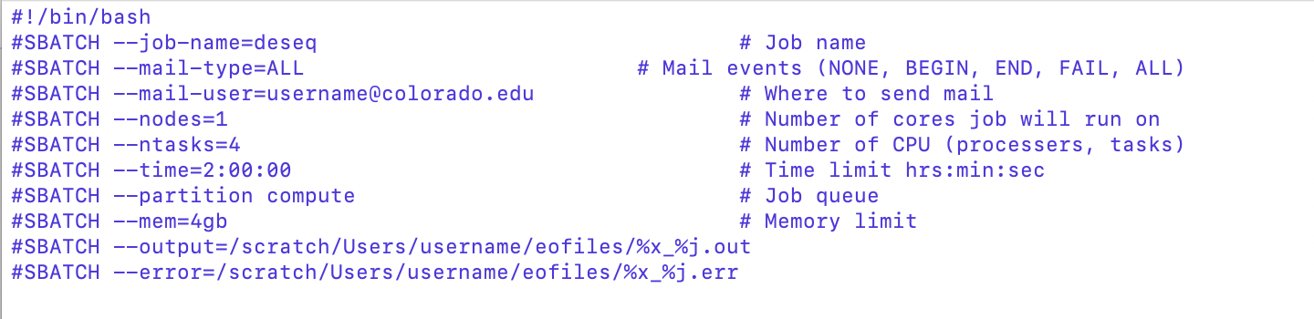

becomes

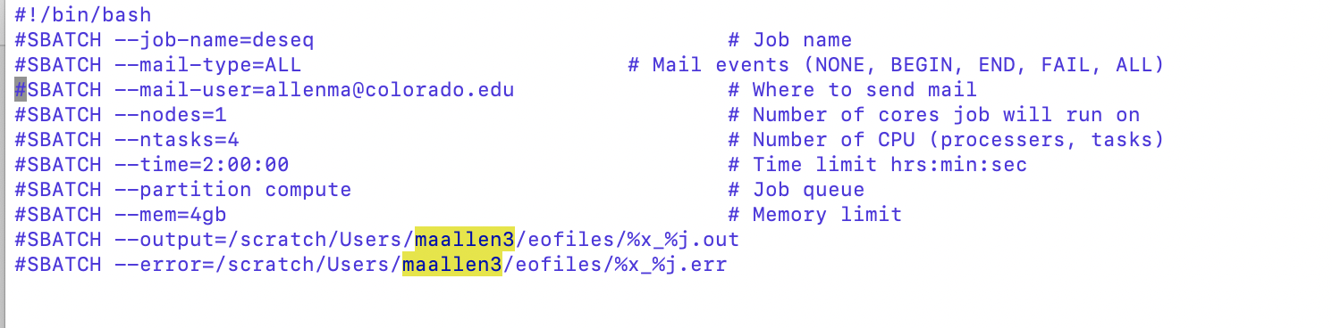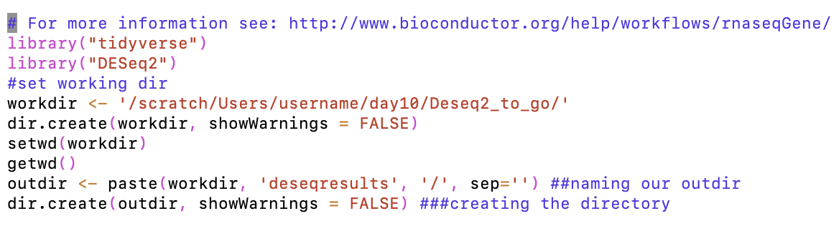

becomes

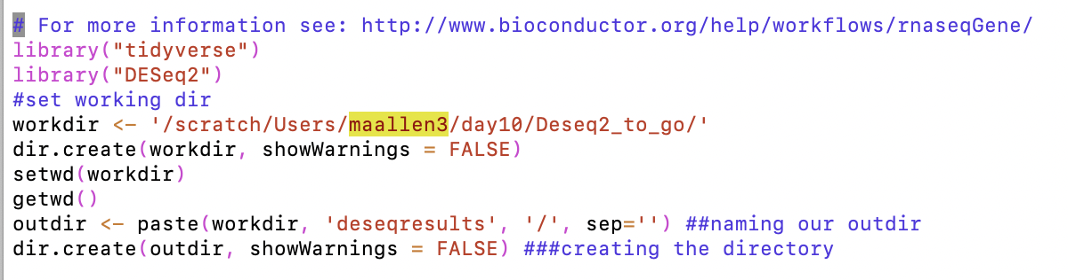

Step 3) Submit the sbatch script to the queue

The sbatch script runs the R script… how?



Look at the number of genes in each csv

Step 4) If it works you will end up with a directory named deseqresults in your working directory. In the deseqresults directory you will end up with many files.

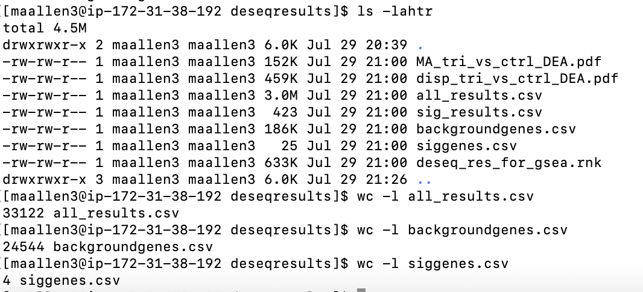

Why are there less background genes than all_results genes?