Monday Summery

There are three types of operating systems: Mac, Linux and PC. If you want a laugh you can check this out. <https://www.youtube.com/watch?v=gAc2oSgCZZI>

Mary showed the in class slides 1

Amber showed the in class slides 2

We talked about the most common file types in Short read sequencing:

Most of what you need to know about this morning was covered in this:

<https://www.bioconductor.org/help/course-materials/2015/LearnBioconductorFeb2015/A01.3_BioconductorForSequenceAnalysis.html>

Fastq

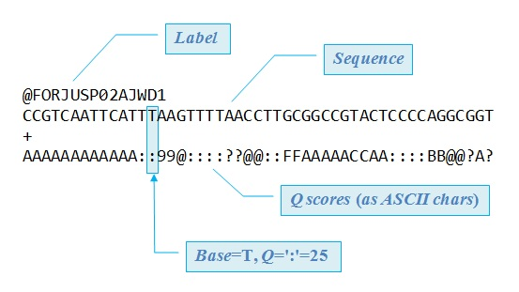

bam file is sam file but binary



Fastq

trimming (optional)

check quality



Bam/

Sam

Mapping

file type : black text

process: blue text

To find out what a file type is…

<https://genome.ucsc.edu/FAQ/FAQformat.html>



Bed file

Counts file

(no standard designation)

csv

tab

txt

vcf file

smaller visualization files

Bedgraph

BigWig

tdf

Chip-seq, Clip-seq, ATAC-seq

RNA-seq

DNA-seq

Most

Bam/

Sam

in class work:

1. Log in
   1. If you are on a PC start bash/Ubuntu or Moboxterm. If you are on a mac start a terminal (search for terminal and click)
   2. Type ssh <username>@<IP/server name>
      1. For example, this is how I log into our amazon instance 52.14.43.129 (only available during the short read workshop for those who sent bit-help there github username)
         1. [maallen3@52.14.43.129](mailto:maallen3@52.14.43.129)
         2. You try this?
            1. If logging in does not work, and you have followed the instructions on the before workshop website and it is during the two weeks of class, please talk to us Tuesday morning
      2. To log on to Fiji (only for BioFrontiers members who have talked to IT and gotten an account on fiji)
         1. [allenma@fiji.colorado.edu](mailto:allenma@fiji.colorado.edu)
   3. if you are asked a yes/no question the answer is yes
   4. if you are asked for a passphrase just hit enter without typing
2. try vim
   1. type vim to start
   2. type :q! to exit
3. try vimtutor
   1. type vimtutor
   2. to exit type :q!
4. leave the server
   1. type exit or logout

Last advice:

Google a “vim cheat sheet” and a “unix cheat sheet”

Print or save--- you will use this a ton!